Links for Reading at Home
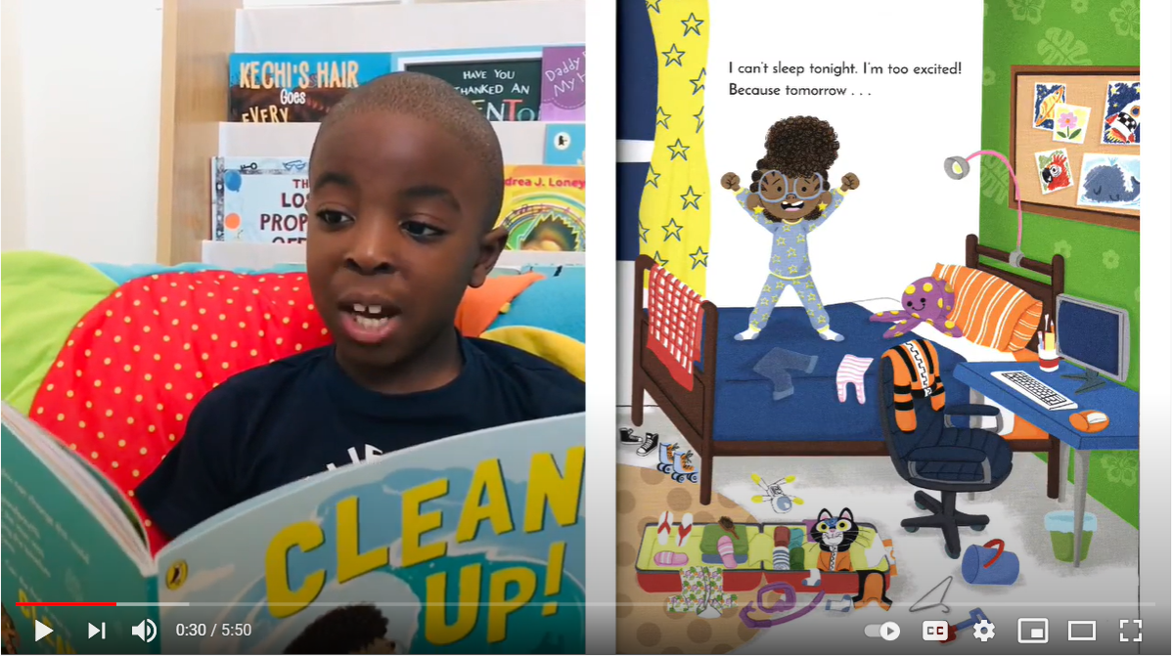  Kid’s Fun Learning | 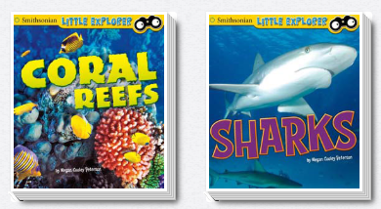  Free e-books | 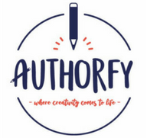 | 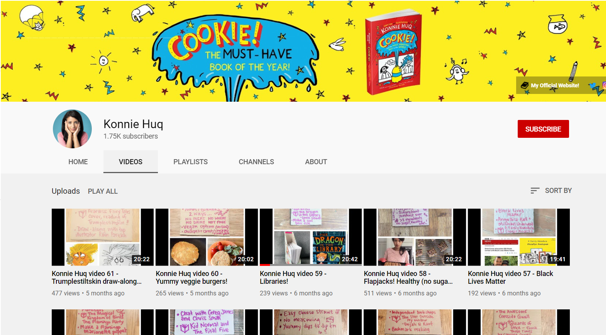  Konnie Huq’s Youtube Channel
Lots of videos of some great books being read aloud.  https://www.youtube.com/channel/UCrFMow5TKHosUmHtVIzuAwg | Some fantastic e-books.  https://www.oxfordowl.co.uk/for-home/find-a-book/library-page/  Storytime sorted by ages.  https://www.booksfortopics.com/storytime-online | Authorfy have some great 10 minute challenges from authors and there is even more book fun on their website. You can sign up for a free account. https://authorfy.com/10minutechallenges/ | Lots of videos about interesting topics. There are also some great interviews with authors.  https://www.youtube.com/channel/UCDlSobQTc4IifJEu6Lt22eA/videos
 | 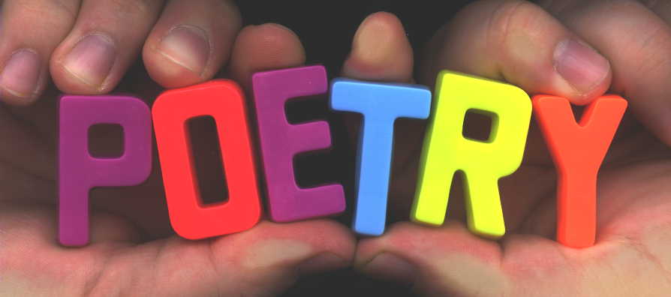 |   The Reading Realm | 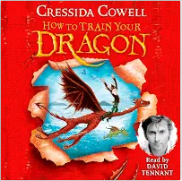  Cressida Cowell
Here are some links to help you and make your own comics.  http://davidoconnell.uk/activities/comics-drawing/  http://fdslive.oup.com/www.oup.com/oxed/children/kevin-comic-sheets.pdf | Lots of links where you can read, watch, hear and explore children’s poems.  https://clpe.org.uk/poetryline  https://www.poetrybyheart.org.uk/  https://www.poetryfoundation.org/learn/children  https://childrens.poetryarchive.org/ | Learning from home resources, ideas and more. There is also an app you can get with lots of things to read and activities. https://thereadingrealm.co.uk/category/resources/ | On her YouTube channel, children’s author Cressida Cowell reads extracts from her books like How To Train Your Dragon and shares other magical ideas.  https://www.youtube.com/channel/UCe01xn13M8q2dsIw0mvW9lg
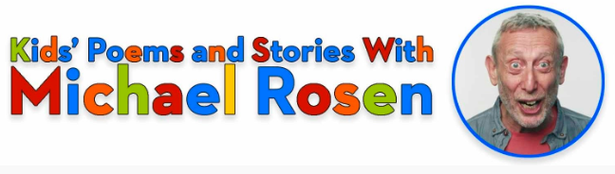  Michael Rosen YouTube | 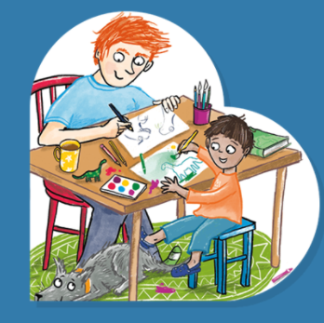  Love Reading 4 Kids |   Book Trust Home Time | 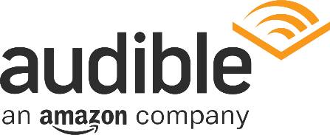  Free audio books
Over 400 videos of Michael Rosen reading his children’s stories and poems.  https://www.youtube.com/channel/UC7D-mXO4kk-XWvH6lBXdrPw | Books, videos and competitions  https://www.lovereading4kids.co.uk/kids-zone/ | Lots more book fun, quizzes and videos here. https://www.booktrust.org.uk/books-and-reading/have-some-fun/?q=&sortOption=AtoZ&pageNo=1 | Lots of free audio books for children to explore. https://stories.audible.com/discovery

