Shadow Drawing - Light And Shadow Experiment
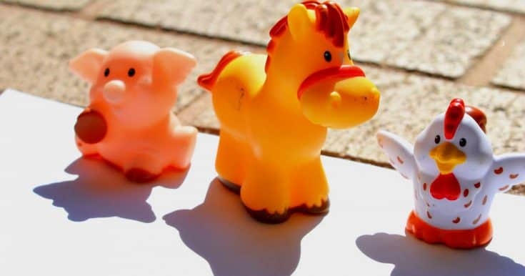
Drawing with light and shadow is such an easy and yet fun activity for little kids.
It really helps them recognize and understand several important concepts in physics.
By observing the different (funny) shapes created by sunlight at different time of the day, children may even become more creative!
Warning: Looking at the sun directly can permanently damage your eyes.

Materials
- several toys
- paper
- marker

Tools
- sunglasses
- sunscreen
- adult supervision

Instructions
- Choose a time to do this experiment. Do this in early morning or late afternoon.
- Put on sunscreen and wear sunglasses. :)

- Place the toys on the paper.
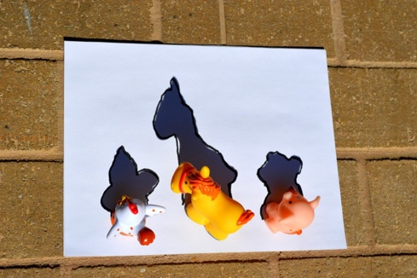
- Using the marker, trace the outline of the shadows on the paper.
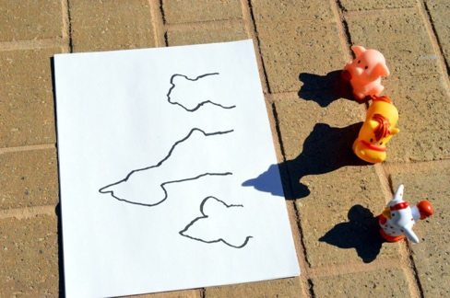

Notes
- Do the shadow stay the same? How do they change with time?
- Are the shadows larger, the same size or smaller than the toys?
- When you rotate the toys, what happens to the shadows?

