Acrostic poems
In an acrostic poem the first letter of each line spells out a word related to the topic. Have a look online or in some poetry books to find some examples. Acrostic poems do not have to rhyme.
My pirate acrostic poems:
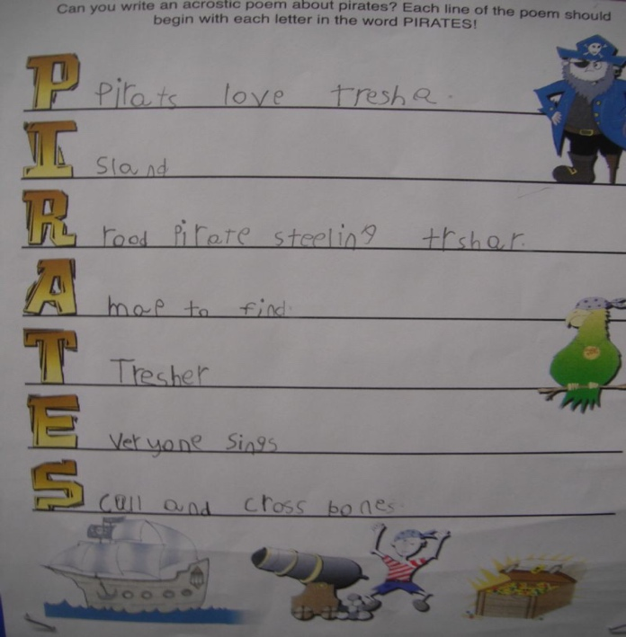
I have used the word PIRATE in both of these examples, but one has full lines and the other uses just single words to describe a pirate.

Plundering treasures from golden chests
I am a Pirate!
Roaring loud
Ahhh I scream
Treasure islands are where I land
Emerald seas and golden sand

Plunderer
Ill-tempered
Rioting
Angry
Treasure-hunter
Enemy

Have a go at writing your own pirate acrostic poem. You can use the word pirate as I have or a word associated with pirates such as flag, parrot, treasure etc. Next, think of words that begin with each of the letters of your chosen word – they might be other words to do with pirates, like I wrote ‘Treasure islands’ for the letter ‘T’, or a good word to describe something to do with pirates, like I wrote ‘Emerald seas’ for the letter ‘E’.

Acrostic poems also make nice artwork. Once you have finished your poem, draw the first letters of the lines in big bubble writing and fill them in with patterns and colours. You could also add illustrations.

