Here is a more detailed explanation of some of the activities on Week 2’s timetable.

I hope this helps.

The sheets needed are included online with these plans.

Any questions please use the Ruby Class email.
Rhyming Eye Spy- Lay all the matching pairs on the floor.
Choose a picture and Fred Talk the word.
Ask child to find the matching partner and Fred Talk their chosen one.
Discuss any errors and look at similarities in the spelling e.g last sound.
Challenge-Adult chooses an object in the room/garden and says a word that rhymes with it. Child guesses which item they have chosen e.g. “I spy something that rhymes with plate! (gate)” Fred Talk and write each new word.
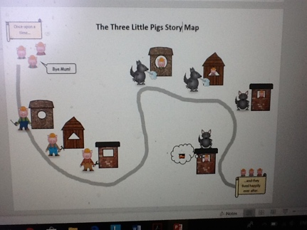
Story Maps- Choose a favourite and familiar book to read together.
Talk about the beginning, middle and end.
Discuss the characters and the main events.
Draw a story map on a large piece of paper. A3 or A4.
Make a path through the story starting with an opening illustration.
Add each event as it happens.
Finally draw the ending.
Challenge- Add captions e.g. Pig number 3 was happy in his brick house.
Shape Hunt- What shapes can you find around your home?
Search rooms or the garden.
Describe what you can see and explain what features that shape has.
Convince each other that is a certain shape e.g. “The TV screen is a rectangle because it has 2 shorts sides and 2 longs sides opposite each other”
Record on the tally chart and count up at the end.
Which shape did you find the most?
Challenge- Learn the names of the new 2d shapes.
Can you describe the 3D shapes around you? Convince others of you reasoning.
Build a tower game- Tower race.
Use objects preferably bricks to build the tallest tower.
Set a timer to 2 mins.
The winner is the player who has the tallest tower still standing.
Compare sizes and discuss differences.
Challenge- Each player starts with 1 Lego or wooden brick.
Roll a dice and add that many bricks each time. Discuss how many more each time.

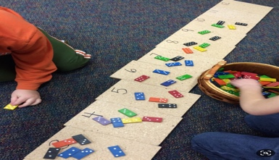
Write and Count Objects- Practice writing numbers to 10.
Use the number formation sheets as a guide.
Write numbers on pieces of paper or post-its.
Count out objects on to each number carefully.
Challenge- Do the same with numbers to 20 and beyond.

Pairs- Count objects in twos.
Find objects that need to be in pairs e.g the sock drawer.
Sort the objects into 2’s.
Begin to say the 2 times-table.
What numbers are missing?
Challenge- Make labels for pairs e.g 2, 4, 6 to 20

